**Exercise # 01**

**SWE 312: Theory of Computing Faculty: Fatama Binta Rafiq (FBR)**

**…………………………………………………………………………………………………………………………………………..**

1. The following is the state diagram of DFA. Answer the following questions about these machines.

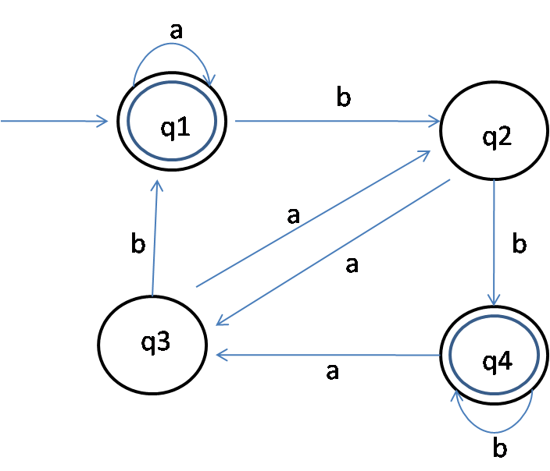

1. What is the start state?
2. What are the set of accept states?
3. What sequence of states does the machine go through on input **abab**?
4. Does the machine accept the string **abab**?
5. Does the machine accept the string **ε** (epsilon)?

2. The following is the state diagram of DFA. Answer the following questions about these machines.

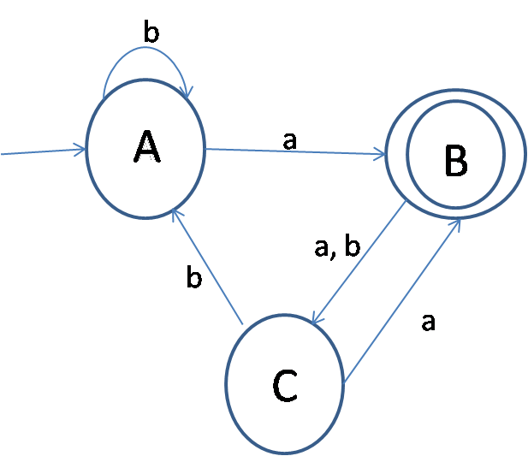

1. Describe the above DFA formally.
2. Is the string aabb accepted by the DFA? Show your works.
3. Is the string bbab accepted by the NFA? Show your works.